Below is the script used to finalize the result-

**Pig –x local;**

**emp_details = LOAD '/home/acadgild/pig/employee_details.txt' USING PigStorage(',') AS (emp_id:int, name:chararray, salary:int, rating:int);**

**odd_emp = FILTER emp_details BY emp_id % 2 != 0;**

**order_sal = ORDER odd_emp BY salary DESC;**

**top3 = LIMIT order_sal 3;**

**final_res = FOREACH top3 GENERATE (emp_id, name);**

**dump final_res;**

Each and every relation has been explained below with its immediate corresponding output-

Start pig in local mode-

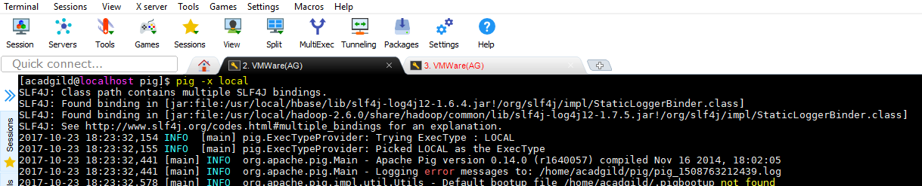

Load the emp_details.txt file using PigStorage

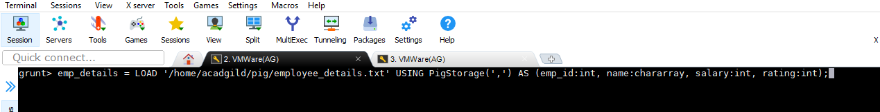

Contents of file-

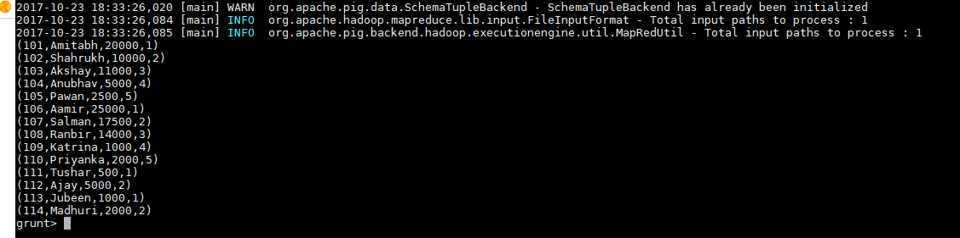

Filtering out the employees with odd emp_id-



Records with odd emp_ids-

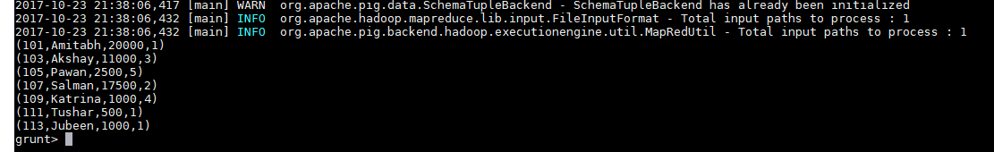

Ordering the salary in descending manner-

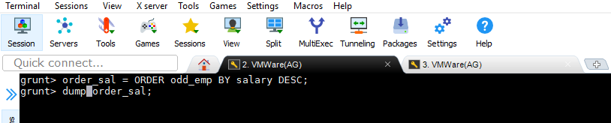

Records with descending order of salary-

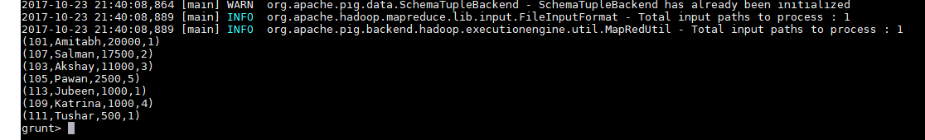

Extracting top 3 rows for top 3 employees with odd emp_id-



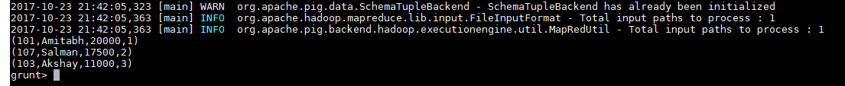

Generating emp_id and emp_name as per question-

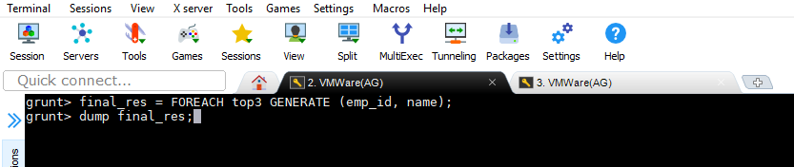

Final output-

